BS6203 Assignment 2
Yaoding Chen

- How do you think simultaneous contrast and metamerism can affect the effective representation of continuous variables using colour?

Simultaneous contrast is a visual phenomenon where two different colours affect each other. If such phenomenon happens to continuous colour variables, the colour gradients may be discontinued visually, although it is not the case. Datacolor.com provides an example of how this affects continuous colour scale, given different colour backgrounds. Although the same green colour is displayed, different background colours makes the green colour unlike each other, thus discontinuing the continuous colour scale.

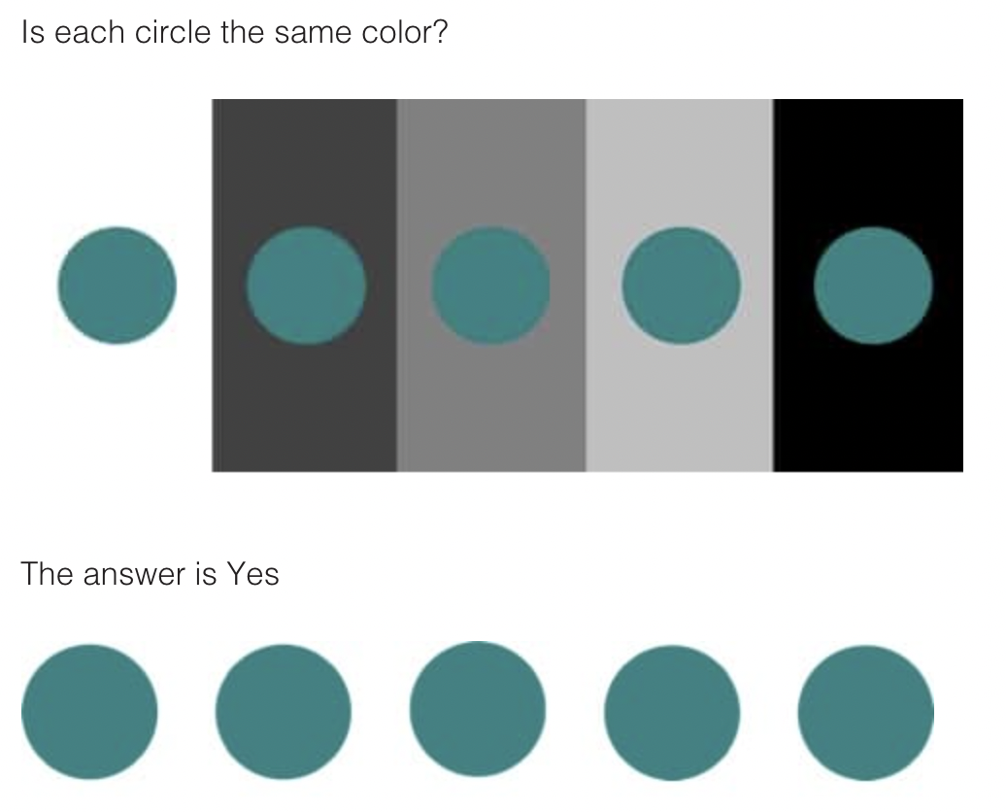

Metamerism is a phenomenon that occurs when two colours appear to match under one lighting condition, but not when the light changes. Thus, as is illustrated below in the figure from datacolor.com given specific lighting condition, different colours may be perceived as either continuous or discontinued.

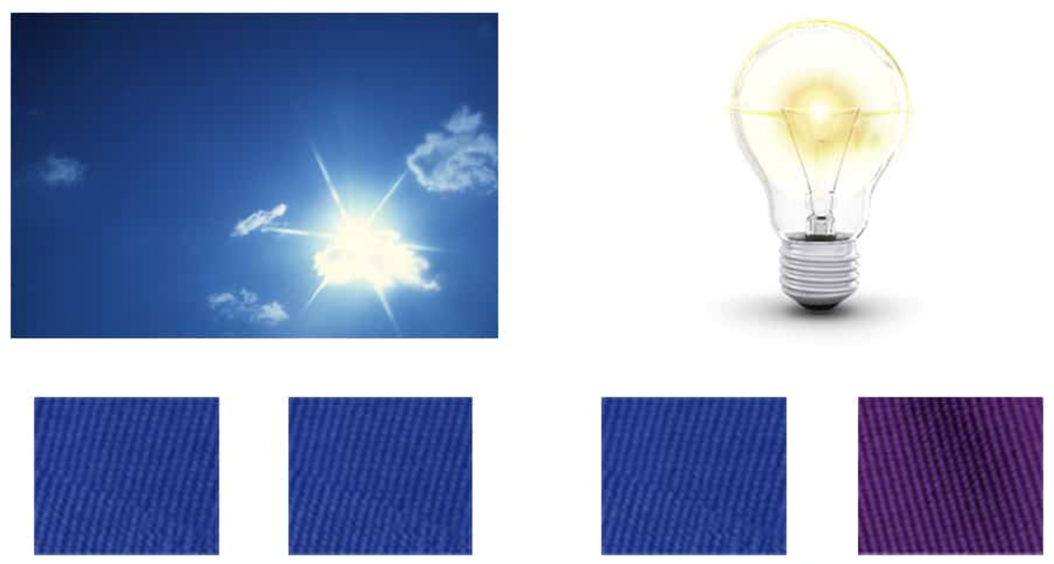

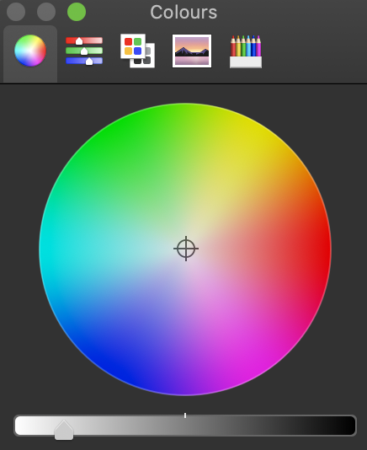
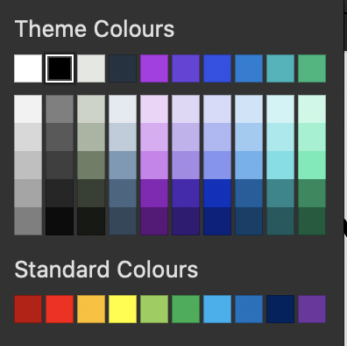

These are the theme colours you can find right in MS PowerPoint. Looking at both rows and columns, outline where the concepts of saturation, hues and lightness are (you can use the colour wheel on the left to help you.

Every colour is described by three properties: hue, saturation and lightness. Hue is the attribute we use to classify a colour as red or yellow. Saturation describes the neutrality of a colour; a red object with little or no white is said to be very saturated. The lightness of a colour tells us about its relative ordering on the dark-to-light scale.

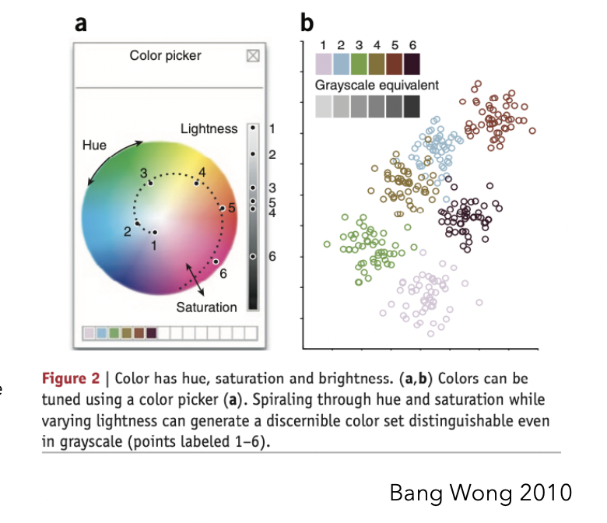
As shown on the right, Wong (2010) provides the below figure which best illustrates the answers to this question. The colour wheel illustrates hue and saturation of the colour, while the lightness of the colour can be adjusted with the scroll next to the wheel. Similarly, different rows in the theme colour panel represent different hues in different lightness.

- Upload the three datasets attached with this assignment, into the “Microbiome submission” tab of the webtool accessible at https://integrative-microbiomics.ntu.edu.sg and click on “Next” followed by “Merge”. This will take you to “Cluster visualisation” tab. Click on “Similarity Plot”. You will see a heat-map appear, play around by changing different options such as colours and data-transformation.

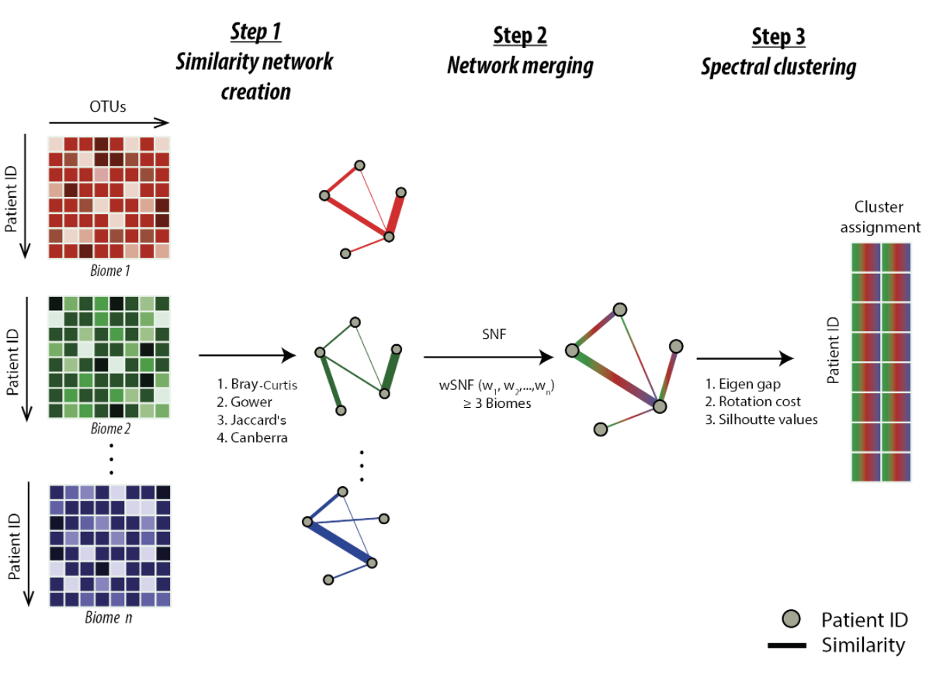

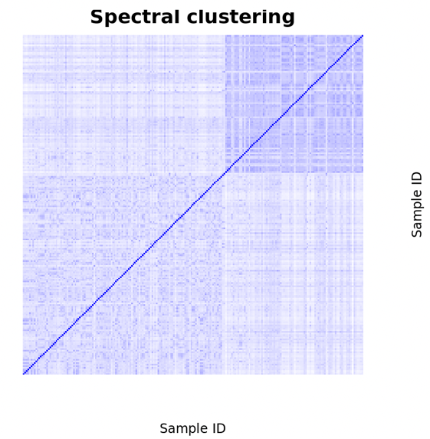
- Relating the concepts learnt in the class, which options of the heatmap do you think represents the clusters in the data, best and worst?
Two colours with distinct hues and huge contrast, such as white and blue, white and red, etc., are the best for visualisation of the results of the weighted similarity network fusion (WSNF). WSNF assumes differential influences of each biome on the overall multi-biome based on individual taxonomic composition and richness. Spectral clustering of the resultant similarity matrix identified two patient clusters, as is exemplified in the figures on the left (made from the online tool provided).

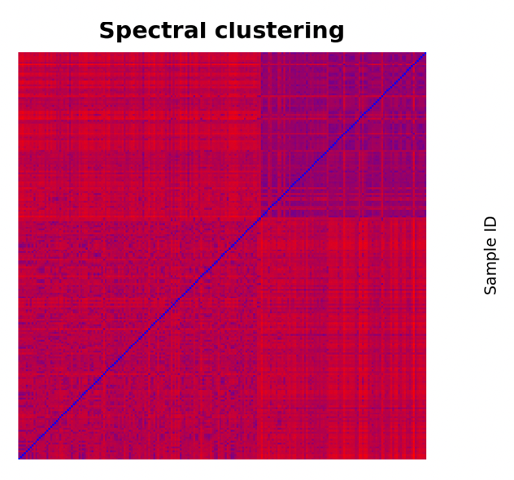
However, even more colours might not be that help to identify the clusters and complicates the problem.

Wong (2011) reasons that colour scale with sharp transition in hue and value can exaggerate specific data ranges, and that juxtaposing colours highly varying in saturation and value can make aspects of the data appear under-represented. For example, using red and blue, which are two colours with sharp transition in hue complicates colour representations of the figure by making it too messy and may exaggerate red regions due to its huge saturation.

- Discuss the advantages and disadvantages of heatmaps?
Advantages:
- As Gehlenborg & Wong (2012) point out, heat map delivers information in an intensive and intuitive way, which allows presentations of high-dimension data, which means data of thousands of different dimensions, to be shown in one graph.
- Using proper colour scales, it may reveal some patterns of the data like in our similarity plots discussed earlier. These plots will be helpful to identifying outliers, tissue subtypes, and novel gene pathways.
- In machine learning, cluster heatmaps of correlation matrices are particularly helpful for identifying blocks of highly correlated samples that violate the independent and identically distributed (IID) assumptions made by most machine learning algorithms. They can also identify blocks of redundant predictors that may reduce predictive performance, increase computation time, or introduce collinearities that interfere with certain modelling techniques.
- cluster heatmaps can help visualize the relationships between top predictive features, particularly when using estimates such as ensemble feature importances that lack a “directionality” that is more traditionally found in the positive or negative sign of linear model coefficients.
Disadvantages:
- As , a major drawback of heatmaps is that it too heavily rely on colour scales. Thus, colour blind people may fail to acquire information and misperception of colour may affect how we recognise the patterns shown in the plots as discussed in the previous question. Also, it may not complex trend of the data, as well as fluctuation of colour sequences. Besides, how we re-order data may also affect how we perceive the figures, and how we interpret the results (Engle et al., 2017).
- Cells that are not closely clustered must still be placed adjacent in the heatmap due to the rigid grid structure. Rows or columns that are closely clustered can also end up non-adjacent in large clusters. To compensate, users must reference the dendrograms in the margins to be certain that visible clusters in the heatmap match the hierarchical clustering depicted in the dendrograms. It can be fatiguing and error-prone to shift focus back and forth between elements (Engle et al., 2017).

- Can you come-up with an alternative representation of this data?

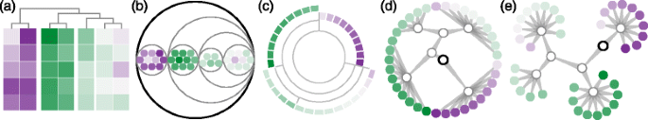

Engle et al. (2017) proposes 5 alternatives to cluster heatmaps, which include:
- gapmap, which is a variant of cluster heatmaps encoding the distance between the clusters as gaps between rows and/or columns
- circle packing shows hierarchy via nested circles instead of squares, with the outermost circle representing the root and the innermost nested circles representing leaves.
- Sunburst are space-filling adjacency diagrams very similar to radial Reingold-Tilford trees, except all nodes are represented by space-filling arcs radiating from the centre of the visualization instead of individual circles. The root is encoded in the centre, inner nodes are represented as nested arcs radiating away from the centre, and leaf nodes are along the outermost rings of the circle.
- radial dendrogram uses polar instead of Cartesian coordinates, the root is in the centre of a circle and the leaf nodes are arranged along the outer-most ring
- force-directed tree an approximation of a physics simulation to calculate node placement, where disconnected nodes repel each other and connected nodes attract each other. This results in a compact node-link diagram.
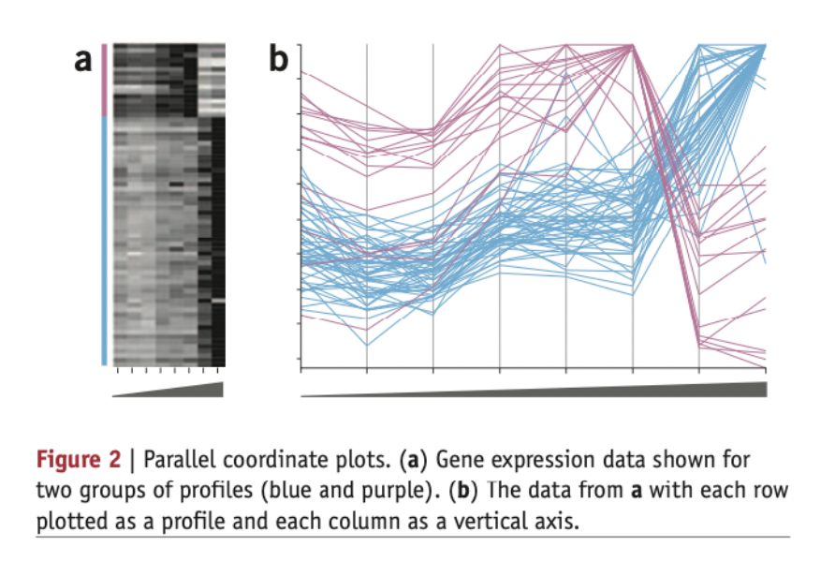
Also, in lecture notes, there is mentioning of parallel coordinate plots, which can also be used to indicate patterns within the data through visual clustering.
- This below figure represents a table showing 3 case scenarios on the columns (where balanced is an easy setup, and severely unbalanced is a challenging setup). Each column is evaluated on 4 metrics, precision, recall, f-score and AUC. You do not need to know what these are, but you only need to know only that the closer to 1, the better. The pre-process describes the use of none (not using any), scaling, quantile and z-score data transformation procedssures before using a batch effect removal algorithm such as Combat, Harman, SVA, Ratio-A and Ratio-G. The no batch and Batch rows refer to the situations where no batch effects exist, and where batch effects were introduced into the data.

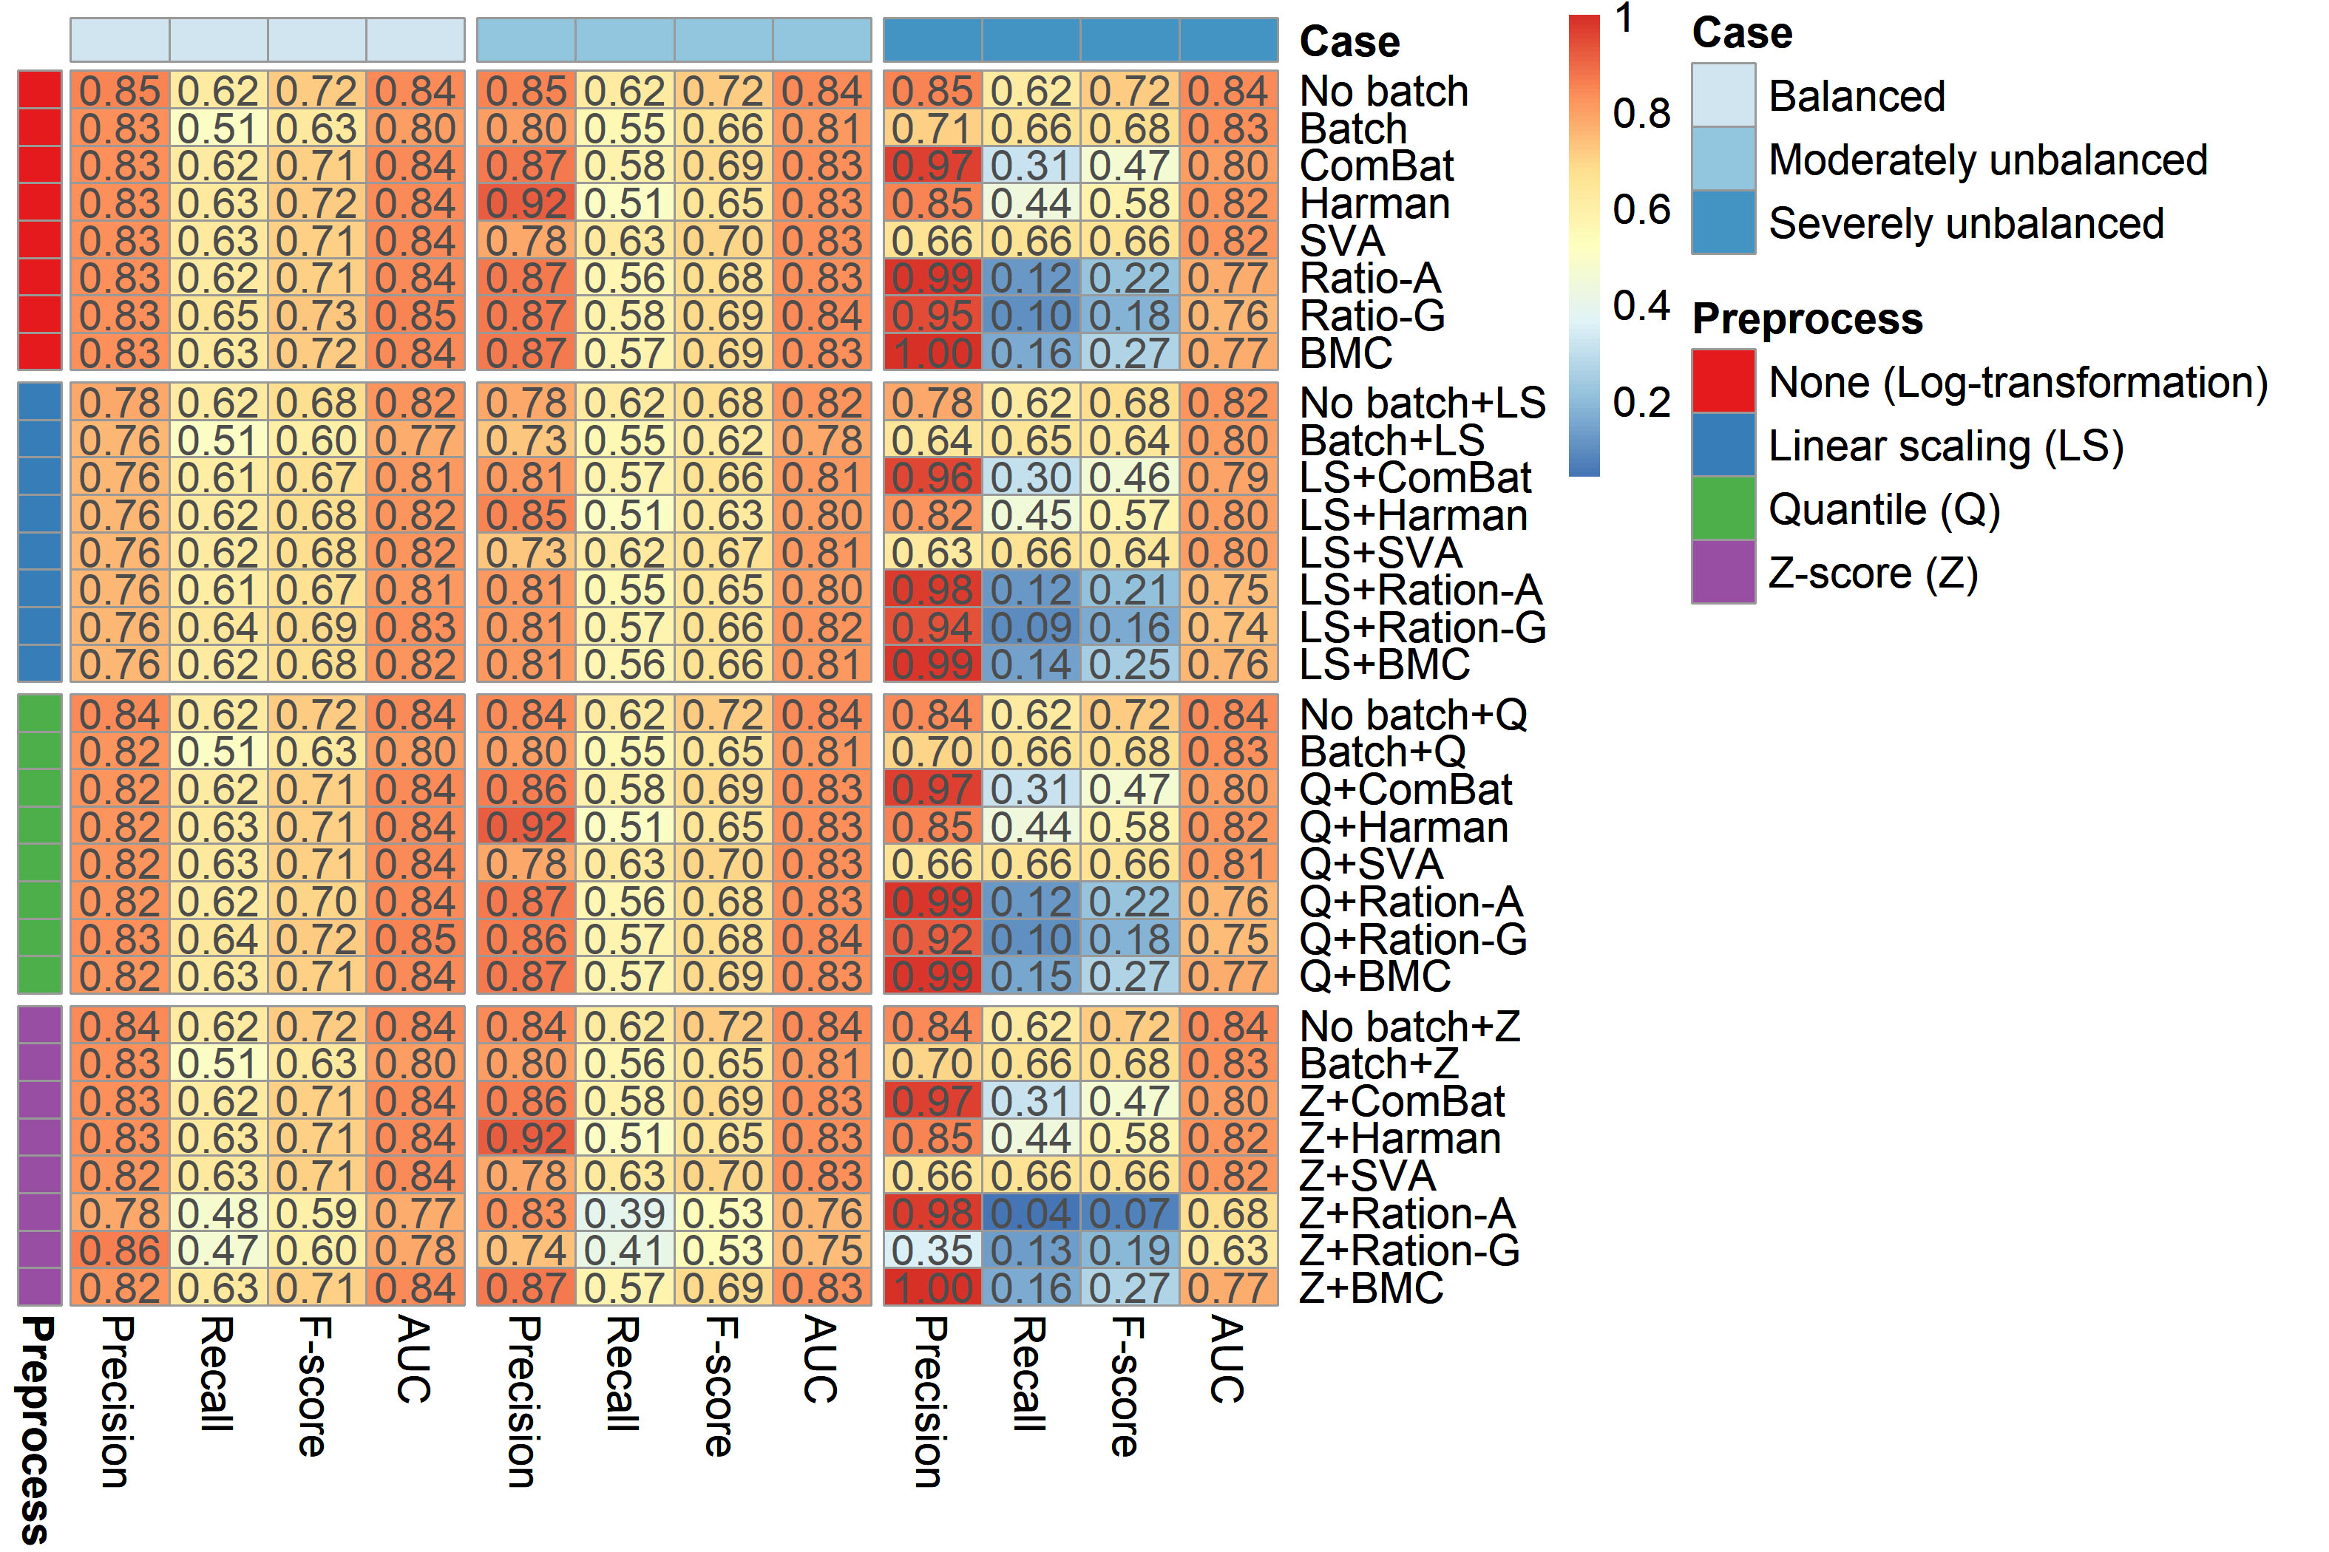

- Which retinal variables are used here?
There are major two retinal variables used here, i.e., luminance/shading and colour saturation.

- And how does one go about interpreting this graph?
The graph is to compare the goodness of fit of different models to analyse different sample. Precision, recall, F-score, and AUC are all parameters of model performance (Zhou et al., 2019).
We may also compare the parameters of models with different preprocesses. Likewise, for different preprocesses, it is interesting to notice that the best model indicated by the parameters are actually quite different, which means the choice for batch effect removal algorithm could be ambiguous and it only has a minor impact on model performance. As described by Zhou et al. (2019), Ratio-A and Ratio-G does not work well with Z-score, which should be the worse choice for batch effect removal.

- References

Engle, S., Whalen, S., Joshi, A., & Pollard, K. S. (2017). Unboxing cluster heatmaps. BMC Bioinformatics, 18(2), 63. https://doi.org/10.1186/s12859-016-1442-6
Gehlenborg, N., & Wong, B. (2012). Points of view: Heat maps. Nature Methods, 9(3), 213. https://doi.org/10.1038/NMETH.1902
Wong, B. (2010). Points of view: Color coding. Nature Methods, 7(8), 573. https://doi.org/10.1038/NMETH0810-573
Wong, B. (2011). Points of view: Avoiding color. Nature Methods, 8(7), 525. https://doi.org/10.1038/NMETH.1642
Zhou, L., Chi-Hau Sue, A., & Bin Goh, W. W. (2019). Examining the practical limits of batch effect-correction algorithms: When should you care about batch effects? Journal of Genetics and Genomics, 46(9), 433–443. https://doi.org/10.1016/J.JGG.2019.08.002

